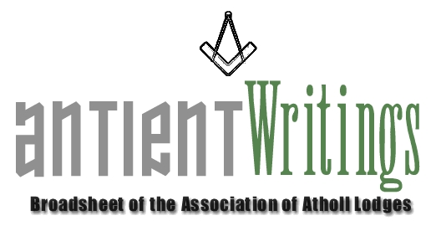

2nd Edition, 2006

New Vice President - W Bro. Keith Tallon

The Association has a new Vice President. Keith is the Deputy Chairman of the Sussex Group of the Metropolitan Grand Lodge and is already getting involved and helping the Association with their forthcoming events.

RA Chapters

If you are a lodge which has a ‘linked’ RA Chapter who would like to enjoy the benefits of the Association by subscribing please contact Rod Letherby on 020 8690 6749 or email roderick@rletherby.freeserve.co.uk . Subscriptions have been retained at the reduced level for 2007 [Full & Associate £15 - Affiliate £10 Lodge] but this will be abated to £10 and £7 for Chapters providing their ‘host’ Atholl lodge is subscribing. Also it will be free of charge from the date of joining until the next payment year [Jan-Dec]. Lodges and Chapters may notate their summons: A Member of the Association of Atholl Lodges

Help Required

If you are interested in joining the Executive Committee, which meets 3 times a year in London, please make contact with the Secretary who is always keen to involve new blood and share interests with Atholl brethren.

Dermott 2006 – The Main Event

2006 is the 250th anniversary of the publication of Laurence Dermott’s constitution Ahiman Rezon [1756]. The Association has planned an ‘event year’ with displays and talks about this unsung collossus of Antient freemasonry. The Library and Museum at Great Queen Street are mounting a Dermott display for the second half of the year.
Reserve a slot in your diary and book early for:

SAT JULY 22ND 2006….. London Event - Displays & Luncheon - Gt Queen St [10am-4pm]

All are welcome – masons and non-masons – their friends and families. This will be a non-regalia event at Freemasons Hall with many VIPs present. It will be followed by luncheon at the New Connaught Rooms. Why not make a day of it in London with your family and friends and show them your ‘Atholl’ heritage. Full information see…./over…..

A Brothers Assistant – The Laurence Dermott Story

A special 40 page illustrated book has been printed, telling the story of Laurence Dermott. An advance ‘complimentary’ copy will be given to each Atholl lodge. They will be available at the various events throughout the year. But if you would like a copy now please contact the Secretary. They are £6 including postage. See …./over..

Annual General Meeting

The 2006 Annual General Meeting will be held at FM Hall Great Queen Street London on Wed 5th July starting at 6pm. Any subscribing lodge or member who wishes to submit a Notice of Motion may do so by writing to the Secretary by 7th June. All are welcome at the AGM. Especially those who want to get ‘involved’.

Would Secretaries and Representatives photocopy and distribute as widely as possible

Paul Gardner
39 Wentworth Drive, Bedford, BEDS, MK41 8QA
01234 261584 secretary@antients.com

